**“Digital Sheba” Progress Report**

Project Name: Digital Sheba

Project Type: Development

Platform: Web + Mobile Application

Team Name: Young DevOps

Developer’s: i) Md Shahed Talukder

ii) Johirul Islam Joy

iii)Md Jony Miah

iv)Most Sultana Akter Surovi

Email: [shahedtalukder51@gmail.com](mailto:shahedtalukder51@gmail.com)

Date/Time: Started September 27, 2020

Target Date: December 15, 2020

Progress of work percentage: 20%

|  |
| --- |
| Reporting Period Dates covered by report(Oct 27, 2020) |
| Section One: Summary |
| We are already in the process of the home page development of our project including some work of the project such as work plan, project design planning(UI/UX) and requirement analysis. |
| Section Two: Activities and Progress |
| We already have done many steps for our System. Like,   * Requirement Analysis: Completed * Software Requirement Analysis: Completed * System Analysis and Design: Completed * UI/UX Design: Complete * Home Page Development: Work in Progress * Project Repository Creation: Completed |
| Section Three: Remaining Work Item |
| * Home Page * About Page * Contact Page * Dashboard Development * Authentication Module Development * Feedback Page * Doctor Page * Nurse Page * Assistant Page |
| Section Four: Experienced Challenges |
| We are very new to make project like this. So this was quite challenging for us. We have faced some problems regarding introduced with new technologies for front-end and also for back-end. We also faced some problems like Requirement Analysis, Diagram Making, UI/UX design etc.) |
| Section Five: How were the challenges handled? |
| We encountered many problems while doing our project . Then everyone in our group members research a lot and found a solution to the problem |
| Section Six: Outputs and Deliverables |
| Already our Requirement analysis, System Analysis & Design work has been completed. And these are now fully prepared for submission |
| Section Seven: Outcome and Lessons Learned |
| We hope we get a lot of benefits from this project and there are a number of things we have learned such as,   * Requirement analyzing: it defines all requirements for project. * Project mapping: it define full working process for the project * UI/UX design: it gives an idea about the complete design of a project based on which the project progress is taken forward. |
| Section Eight: Message |
| This was a new experience for us and we have learned a lot of things from it. |

Raw Requirement

1. This will be a web based application for Admin’s, Doctor’s and Doctor’s Assistant.
2. This will be a mobile based application for Nurse and Patients.
3. A registration form will be there only for patient who will provide their information and other user’s like Doctor, Assistant and Nurse’s account will be created by Admin and Admin account will be created by the developer directly and everyone will be able to logged into it after providing their username and password.

For Registration patient will provide:

* 1. Username
  2. Full Name
  3. Age
  4. Address
  5. Email
  6. Password

1. In the system patient will be able to get these facilities
   1. Get notified about medicine
   2. Get present report
   3. Get billing information
2. Patient will be able to give feedback about the services they get.Patient will be able to send problem report if they face any.

Categories of Problem:

* 1. Getting Seat
  2. Medicine Not Found
  3. Nurses not properly serving
  4. Other

1. In the system doctor will be able to do this stuffs.
   1. Give Prescription
   2. Review Patient Health
   3. Assign Nurse
2. Updating report of a patient is also a feature here to give patient recent condition directly for doctor. In the system nurse will be able to do this stuffs.
   1. Get patient information
   2. Allocate Assigned Medicine
   3. Monitor Patient Health
   4. Give medicine to patient
   5. Generate Patient Report
3. In the system assistant of a doctor will get this stuffs to do here:
   1. Update Medicine Info
   2. Maintain Patient Info
   3. Update Assigned Nurse
   4. Generate Bill
   5. Update Bill
4. Doctor’s and Admin’s will be able to see patient’s feedback to commemorate and deal with their problem.
5. Admin will have the full power of controlling the whole system. He will be able to any kind actions if needed for system and here is these stuffs that he can do:
   1. Authorize patient’s account
   2. Update patient information
   3. Delete Patient information
   4. CRUD For Doctor
   5. CRUD For Nurse
   6. CRUD For Assistant
6. Setting bill to patient profile is a feature for admin.
7. Admin will provide full technical support to all of those users that have accounts on the system

**Software Requirement Specifications:**

|  |  |  |  |  |
| --- | --- | --- | --- | --- |
| SRS-ID | SRS-Name | SRS-Description | SRS-Type | Priority |
| FR-001 | Web Based Application | This will be a web based application for Admin’s, Doctor’s and Doctor’s Assistant. | Functional | High |
| FR-002 | Mobile Based Application | This will be a mobile based application for Nurse and Patients. | Functional | High |
| FR-003 | Single Page Application | The whole system will be a single page application | Functional | High |
| FR-004 | Registration/Login | A registration form will be there only for patient who will provide their information and other user’s like Doctor, Assistant and Nurse’s account will be created by Admin and Admin account will be created by the developer directly and everyone will be able to logged into it after providing their username and password.  For Registration patient will provide:   1. Username 2. Full Name 3. Age 4. Address 5. Email 6. Password | Functional | High |
| FR-005 | Services For Patient | In the system patient will be able to get these facilities   1. Get Notified About Medicine 2. Get Present Report 3. Get Billing Information | Functional | High |
| FR-006 | Feedback | Patient will be able to give feedback about the services they get. | Non-Functional | High |
| FR-007 | Problem Report | Patient will be able to send problem report if they face any.  Categories of Problem:   1. Getting Seat 2. Medicine Not Found 3. Nurses not properly serving 4. Other | Non-Functional | Medium |
| FR-008 | Services for Doctor | In the system doctor will be able to do this stuffs.   1. Give Prescription 2. Review Patient Health 3. Assign Nurse | Functional | High |
| FR-009 | Change Nurse | Doctor will be able to change assigned nurse if needed according to patients feedback and reported problem | Non-Functional | High |
| FR-010 | Update Report | Updating report of a patient is also a feature here to give patient recent condition directly for doctor | Non-Functional | High |
| FR-011 | Services For Nurse | In the system nurse will be able to do this stuffs.   1. Get patient information 2. Allocate Assigned Medicine 3. Monitor Patient Health 4. Give medicine to patient 5. Generate Patient Report | Functional | High |
| FR-012 | Services For Doctor’s Assistant | In the system assistant of a doctor will get this stuffs to do here:   1. Update Medicine Info 2. Maintain Patient Info 3. Update Assigned Nurse 4. Generate Bill 5. Update Bill | Functional | High |
| FR-013 | Getting Feedback | Doctor’s and Admin’s will be able to see patient’s feedback to commemorate and deal with their problem. | Non-Functional | Medium |
| FR-014 | Admin Services | Admin will have the full power of controlling the whole system. He will be able to any kind actions if needed for system and here is these stuffs that he can do:   1. Authorize patient’s account 2. Update patient information 3. Delete Patient information 4. CRUD For Doctor 5. CRUD For Nurse 6. CRUD For Assistant | Functional | High |
| FR-015 | Set Bill To Patient | Setting bill to patient profile is a feature for admin. | Non-Functional | High |
| FR-016 | Technical Support | Admin will provide full technical support to all of those users that have accounts on the system | Functional | High |

Software Requirements:

* Windows 7 or Higher
* Any Kind of Browser without Internet Explorer

Hardware Requirement:

* Processor: Core 2 Duo
* Hard Disk: 2GB
* Memory: 1GB

Technology Stack:

This system will follow Full-Stack

1. Language: Python
2. Front-end Framework: React.js and React Native(For mobile Application)
3. Back-end Framework: Django Rest Framework
4. Database: MySQL
5. Hosting: Name cheap(Shared Hosting)
6. Tools: Github, Trello, Visual Studio Code, Gitbash, Lucide Chart

**Use Case Diagram**

**User Diagram for Patient**

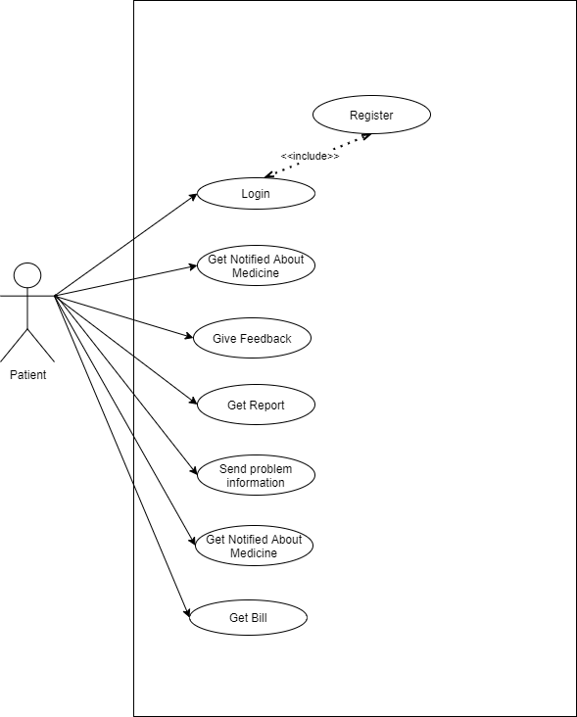

**Use Case Diagram for Doctor**

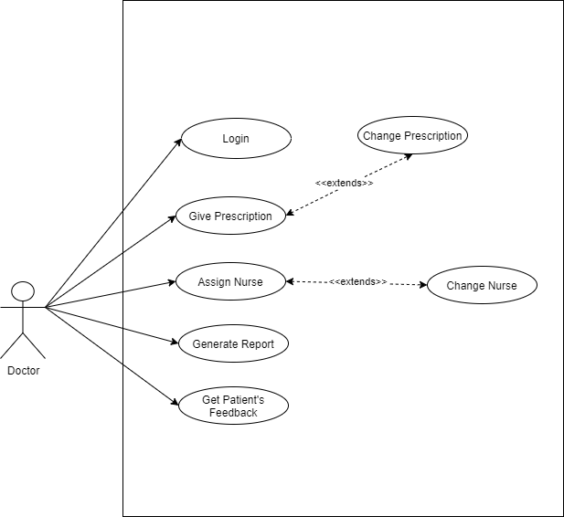

**Use case diagram for nurse**

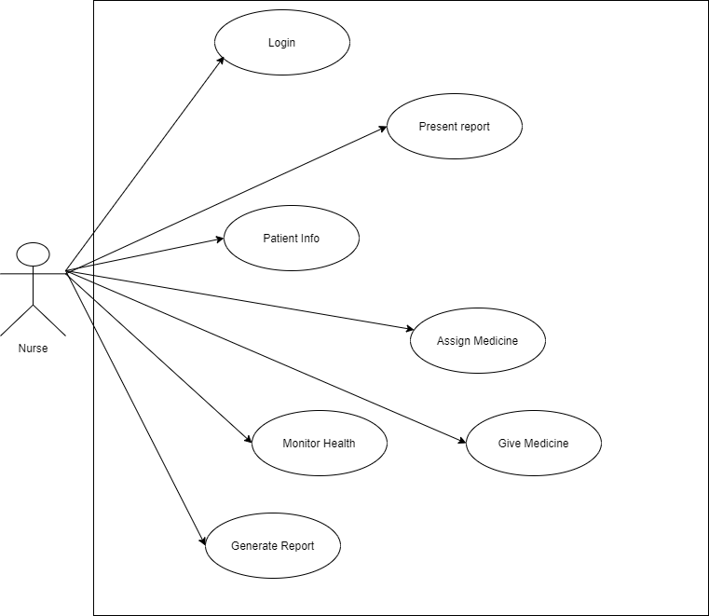

**Use case diagram for assistant**

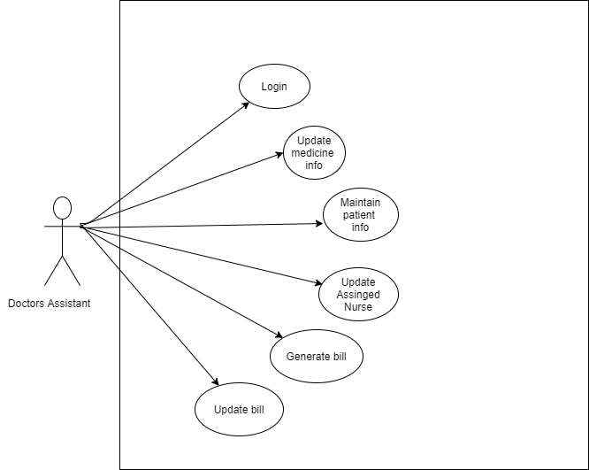

**Use Case diagram for admin**

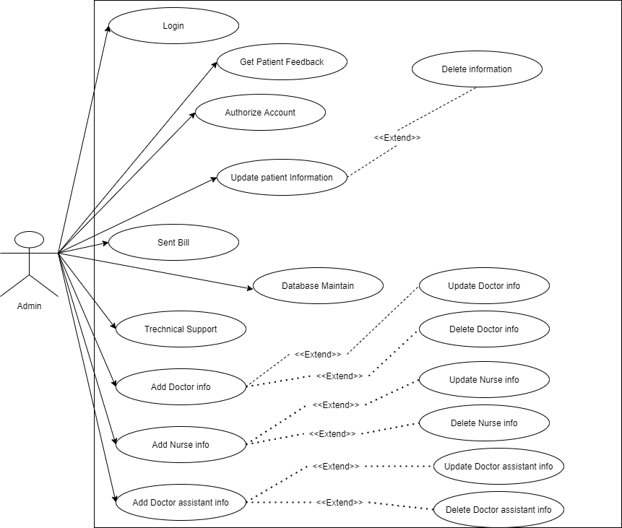

**USE CASE DESCRIPTION**

|  |
| --- |
| **Use Case [1]: Register** |
| **Description** |
| Patients must register first to access the online services of the system via website. |
| **Trigger** |
| Someone enters the website and clicks register button |
| **Actors** |
| Patient |
| **Precondition** |
| Patient should open mobile application with active internet connection and should not have an existing account |
| **Post Condition** |
| Patients accessing online can use all services that has been made for them after registration |
| **Success Scenario** |
| A patient without an existing account accesses the website and registers himself/herself filling the registration form appropriately. |

|  |
| --- |
| **Use Case [2]: Login** |
| **Description** |
| Patients must be registered before logged into it and other user accounts must be created via admin |
| **Trigger** |
| Someone enters the website and clicks login button |
| **Actors** |
| Patient, Doctor, Doctor’s Assistant, Nurse, Admin |
| **Precondition** |
| Only patient will be accessible through mobile application and other users have to be connected through web and active internet connection will be required for it. |
| **Post Condition** |
| After successful login, all users can use all online services of the system which have been provided for them. |
| **Success Scenario** |
| Every user with an existing account accesses the website and logins with accurate credentials |

|  |
| --- |
| **Use Case [3]: Get Notified About Medicine** |
| **Description** |
| Patients will be get notified every time when it’s time to take medicine also a nurse will be there to check them first before taking the medicine. |
| **Trigger** |
| Someone will check the notification |
| **Actors** |
| Patient |
| **Preconditions** |
| 1. Patient must have an existing account. 2. Patient or his family will visit that mobile application to check the notification with active internet connection. |
| **Post Conditions** |
| Patient can check notification about which medicine have been assigned for that time. |
| **Success Scenario** |
| Someone accesses the system and get notification |

|  |
| --- |
| **Use Case [4]: Give Feedback** |
| **Description** |
| Patients will be able to give feedback about nurse or assistant which has assigned for him/her if he/she feel that the services are not enough or not properly doing. |
| **Trigger** |
| Someone will start typing the feedback and click submit button. |
| **Actors** |
| Patient |
| **Preconditions** |
| 1. Patient must have an existing account. 2. Patient or his family will visit from mobile application and login into it to give feedback |
| **Post Conditions** |
| Patient will give feedback to doctor |
| **Success Scenario** |
| Someone accesses the system and write on feedback section and submit it. |

|  |
| --- |
| **Use Case [5]: Send Problem Info** |
| **Description** |
| Patient will be able to send his problem if he/she face any and that will be another section from feedback. |
| **Trigger** |
| Someone will start typing the problem and click submit button. |
| **Actors** |
| Patient |
| **Preconditions** |
| 1. Patient must have an existing account. 2. Patient or his family will visit from mobile application and login into it to send problem |
| **Post Conditions** |
| Patient will send information about his problem |
| **Success Scenario** |
| Someone accesses the system and write on problem information section and submit it successfully. |

|  |
| --- |
| **Use Case [6]: Get Patient Present Report** |
| **Description** |
| Patient will be able to see his present condition. |
| **Trigger** |
| Someone will visit and click report button |
| **Actors** |
| Patient |
| **Preconditions** |
| 1. Patient must have an existing account. 2. Patient or his family will visit from mobile application and login into it to see the report |
| **Post Conditions** |
| No post condition is applicable for it. |
| **Success Scenario** |
| Someone accesses the system and see the recent condition of patient. |

|  |
| --- |
| **Use Case [7]: Get Billing Info** |
| **Description** |
| Patient will be able to check total billing information after he released from the hospital. |
| **Trigger** |
| Someone will click to Payment Button |
| **Actors** |
| Patient |
| **Preconditions** |
| 1. Patient must have an existing account. 2. Patient or his family will visit from mobile application and login into it to check the bill |
| **Post Conditions** |
| Patient will check total bill after release |
| **Success Scenario** |
| Someone accesses the system and check total billing information successfully. |

|  |
| --- |
| **Use Case [8]: Give Prescription** |
| **Description** |
| Doctor will give prescription |
| **Trigger** |
| Someone will start typing and fill the fields and click submit button. |
| **Actors** |
| Doctor |
| **Preconditions** |
| 1. Doctor must have an existing account. 2. Doctor will visit the webpage provided for him. |
| **Post Conditions** |
| Doctor will give medicine information |
| **Success Scenario** |
| Someone accesses the system and give medicine information successfully |

|  |
| --- |
| **Use Case [9]: Change Prescription** |
| **Description** |
| Doctor will be able to change his prescription also if needed |
| **Trigger** |
| Someone will start typing and fill the fields and click submit button |
| **Actors** |
| Doctor |
| **Preconditions** |
| 1. Doctor must have an existing account. 2. Doctor will visit the webpage provided for him. |
| **Post Conditions** |
| Doctor will give medicine information |
| **Success Scenario** |
| Someone accesses the system and change medicine information successfully |

|  |
| --- |
| **Use Case [10]: Assign Nurse** |
| **Description** |
| Doctor will be able to assign nurse for each patient |
| **Trigger** |
| Someone will start choosing and click submit button |
| **Actors** |
| Doctor |
| **Preconditions** |
| 1. Doctor must have an existing account. 2. Doctor will visit the webpage provided for him. |
| **Post Conditions** |
| Doctor will watch nurse list and choose one for each patient |
| **Success Scenario** |
| Someone accesses the system and choose nurses for the patient and assign them successfully |

|  |
| --- |
| **Use Case [11]: Change Nurse** |
| **Description** |
| Doctor will be able to change nurse according to a patients feedback if needed |
| **Trigger** |
| Someone will start choosing and click submit button |
| **Actors** |
| Doctor |
| **Preconditions** |
| 1. Doctor must have an existing account. 2. Doctor will visit the webpage provided for him. |
| **Post Conditions** |
| Doctor will watch nurse list and choose one for each patient |
| **Success Scenario** |
| Someone accesses the system and choose nurses for the patient and assign them successfully |

|  |
| --- |
| **Use Case [12]: Generate Report** |
| **Description** |
| Doctor will be able to generate report after watching recent condition of a patient |
| **Trigger** |
| Someone will start typing and filling the fields and click submit. |
| **Actors** |
| Doctor |
| **Preconditions** |
| 1. Doctor must have an existing account. 2. Doctor will visit the webpage provided for him. |
| **Post Conditions** |
| Doctor will complete typing all of those fields and submit it |
| **Success Scenario** |
| Someone accesses the system with active internet connection and fill all of those fields and submit it from the webpage which has been provided for him. |

|  |
| --- |
| **Use Case [13]: Get Patients Feedback** |
| **Description** |
| Doctor and Admin will be able to get patients feedback about the service they are getting them. |
| **Trigger** |
| Someone will open page and see the list |
| **Actors** |
| Doctor, Admin |
| **Preconditions** |
| 1. Doctor and Admin must have an existing account. 2. Doctor and Admin will visit the webpage provided for him. |
| **Post Conditions** |
| No post condition is required for this |
| **Success Scenario** |
| Someone accesses the system and start watching those reports |

|  |
| --- |
| **Use Case [14]: Get Patient present report** |
| **Description** |
| Nurses will be able to see patients present report which has been provided from doctor |
| **Trigger** |
| Someone will visit and watch the report |
| **Actors** |
| Patient, Nurse |
| **Precondition** |
| 1. Nurse must have an existing account 2. Nurse will visit the webpage with active internet connection |
| **Post Condition** |
| No post condition is required for this action |
| **Success Scenario** |
| Someone access the provided system and start watching the reports |

|  |
| --- |
| **Use Case [15]: Get patient info** |
| **Description** |
| Nurses will be able to see patient’s information which has been provided by patients. |
| **Trigger** |
| Someone will visit and watch patient info |
| **Actors** |
| Nurse |
| **Precondition** |
| 1. Nurse must have an existing account 2. Nurse will visit the webpage with active internet connection |
| **Post Condition** |
| No post condition is required for this action |
| **Success Scenario** |
| Someone access the provided system and start watching patient’s information |

|  |
| --- |
| **Use Case [16]: Allocate Assigned medicine** |
| **Description** |
| Nurses will be able to allocate which medicine has been provided for his/her patient for which he/she is assigned for |
| **Trigger** |
| Someone will visit and watch medicine names |
| **Actors** |
| Nurse |
| **Preconditions** |
| 1. Nurse must have an existing account 2. Nurse will visit the webpage with active internet connection |
| **Post Conditions** |
| No post condition is required for this action |
| **Success Scenario** |
| Someone access the provided system and start checking medicine names. |

|  |
| --- |
| **Use Case [17]: Monitor Patient Health** |
| **Description** |
| Nurses will monitor patient heath. This action will be done directly. So here the apps will do nothing. |
| **Trigger** |
| No action trigger required for this field. |
| **Actors** |
| Nurse |
| **Preconditions** |
| No precondition required for this. |
| **Post Conditions** |
| No post condition required for this. |
| **Success Scenario** |
| Someone will check current condition of a patient by directly going to them. |

|  |
| --- |
| **Use Case [18]: Update Medicine Info** |
| **Description** |
| Assistant will update medicine info after gathering it from doctor |
| **Trigger** |
| Someone will visit and start typing and click submit button |
| **Actors** |
| Doctor’s Assistant |
| **Preconditions** |
| 1. Doctor’s assistant must have an existing account. 2. Assistant will visit webpage and login into it. |
| **Post Conditions** |
| Assistant will update medicine info |
| **Success Scenario** |
| Someone will visit the webpage and start updating medicine info |

|  |
| --- |
| **Use Case [19]: Maintain patient info** |
| **Description** |
| Assistant will be able to see and maintain patient information when needed |
| **Trigger** |
| Someone will visit and start checking |
| **Actors** |
| Doctor’s Assistant |
| **Preconditions** |
| 1. Doctor’s assistant must have an existing account. 2. Assistant will visit webpage and login into it. |
| **Post Conditions** |
| Assistant will check each and every details of a patient |
| **Success Scenario** |
| Someone will check patient information and give response to doctor |

|  |
| --- |
| **Use Case [20]: Update Assigned Nurse** |
| **Description** |
| Assistant will be able to update assigned nurse after getting the information from doctor. |
| **Trigger** |
| Someone will visit and start typing new information and click submit button |
| **Actors** |
| Doctor’s Assistant |
| **Preconditions** |
| 1. Doctor’s assistant must have an existing account. 2. Assistant will visit webpage and login into it. |
| **Post Conditions** |
| Assistant will update newly assigned nurse for the patient |
| **Success Scenario** |
| Someone will visit the website and update patient information |

|  |
| --- |
| **Use Case [21]: Generate / Update Bill** |
| **Description** |
| Assistant will be generate or update billing information according to service that patients get every day. |
| **Trigger** |
| Someone will visit and start typing new information and click submit button |
| **Actors** |
| Doctor’s Assistant |
| **Preconditions** |
| 1. Doctor’s assistant must have an existing account. 2. Assistant will visit webpage and login into it. |
| **Post Conditions** |
| Assistant will generate and update billing information |
| **Success Scenario** |
| Someone will visit the website and generate or update billing information everyday into the website |

|  |
| --- |
| **Use Case [22]: Authorize Patient Account** |
| **Description** |
| Admin will authorize patient information after their registration to the site. |
| **Trigger** |
| Someone will check patient information and click submit button |
| **Actors** |
| Admin |
| **Preconditions** |
| 1. Admin must have an existing account. 2. Admin will visit webpage and login into it. |
| **Post Conditions** |
| Admin will check patient information and authorize them. |
| **Success Scenario** |
| Someone will visit the website and check patient information each and every details and authorize them. |

|  |
| --- |
| **Use Case [23]: Update patient information** |
| **Description** |
| Admin will be able to update patient information if needed. |
| **Trigger** |
| Someone will visit and start typing new information and click submit button |
| **Actors** |
| Admin |
| **Preconditions** |
| 1. Admin must have an existing account. 2. Admin will visit webpage and login into it. |
| **Post Conditions** |
| Admin will check and update patient information |
| **Success Scenario** |
| Someone will visit and update patient information on demand. |

|  |
| --- |
| **Use Case [24]: Delete Patient Information** |
| **Description** |
| Admin will be able to delete patient information when they will be released from the hospital |
| **Trigger** |
| Someone will visit the website and click delete button |
| **Actors** |
| Admin |
| **Preconditions** |
| 1. Admin must have an existing account. 2. Admin will visit webpage and login into it. |
| **Post Conditions** |
| Admin will delete patient information |
| **Success Scenario** |
| Someone will visit the website and delete patient information. Though deleting information is not a good practice for a system. They basically store them into another portion named (Trash) |

|  |
| --- |
| **Use Case [25]: Set Bill To Patient** |
| **Description** |
| Admin will be able to update billing information which will be generated from doctor’s assistant to patient profile. |
| **Trigger** |
| Someone will visit and start typing new information and click submit button |
| **Actors** |
| Admin |
| **Preconditions** |
| 1. Admin must have an existing account. 2. Admin will visit webpage and login into it. |
| **Post Conditions** |
| Admin will update billing information to patient profile |
| **Success Scenario** |
| Someone will visit the website and update billing information to patient profile every day. |

|  |
| --- |
| **Use Case [26]: Add/ Update/ Delete Doctor** |
| **Description** |
| Admin will be able to manage each and every information of a doctor. Here he will be able to add a new doctor, update that doctor’s information or delete that doctor’s information if needed. |
| **Trigger** |
| Someone will visit and start typing and click submit button or delete button when it needed. |
| **Actors** |
| Admin |
| **Preconditions** |
| 1. Admin must have an existing account. 2. Admin will visit webpage and login into it. |
| **Post Conditions** |
| Admin will manage doctor’s information. |
| **Success Scenario** |
| Someone will visit the website and do those crud operation when it’s needed to do. |

|  |
| --- |
| **Use Case [27]: Add/ Update/ Delete Nurse** |
| **Description** |
| Admin will be able to manage each and every information of a Nurse. Here he will be able to add a new Nurse, update that Nurse’s information or delete that Nurse’s information if needed. |
| **Trigger** |
| Someone will visit and start typing and click submit button or delete button when it needed. |
| **Actors** |
| Admin |
| **Preconditions** |
| 1. Admin must have an existing account. 2. Admin will visit webpage and login into it. |
| **Post Conditions** |
| Admin will manage nurse’s information. |
| **Success Scenario** |
| Someone will visit the website and do those crud operation when it’s needed to do. |

|  |
| --- |
| **Use Case [28]: Add/ Update/ Delete Doctor’s Assistant** |
| **Description** |
| Admin will be able to manage each and every information of a assistant. Here he will be able to add a new Assistant, update that assistant’s information or delete that assistant’s information if needed. |
| **Trigger** |
| Someone will visit and start typing and click submit button or delete button when it needed. |
| **Actors** |
| Admin |
| **Preconditions** |
| 1. Admin must have an existing account. 2. Admin will visit webpage and login into it. |
| **Post Conditions** |
| Admin will manage assistant’s information. |
| **Success Scenario** |
| Someone will visit the website and do those crud operation when it’s needed to do. |

|  |
| --- |
| **Use Case [29]: Database Maintenance** |
| **Description** |
| Admin will be able to see and maintain database information everyday. |
| **Trigger** |
| Someone will visit database and check for vulnerability if needed. |
| **Actors** |
| Admin |
| **Preconditions** |
| 1. Admin must have an existing account. 2. Admin will visit webpage and login into it. |
| **Post Conditions** |
| Admin will manage database. |
| **Success Scenario** |
| Someone will visit into database section and check for security breach. |

|  |
| --- |
| **Use Case [30]: Technical Support** |
| **Description** |
| Admin will be able to give any kind of technical support to any kind of users. |
| **Trigger** |
| Someone will visit and start typing. |
| **Actors** |
| Admin |
| **Preconditions** |
| 1. Admin must have an existing account. 2. Admin will visit webpage and login into it. |
| **Post Conditions** |
| Admin will give technical support. |
| **Success Scenario** |
| Someone will visit the site and watch support tickets. |

**Activity Diagram**

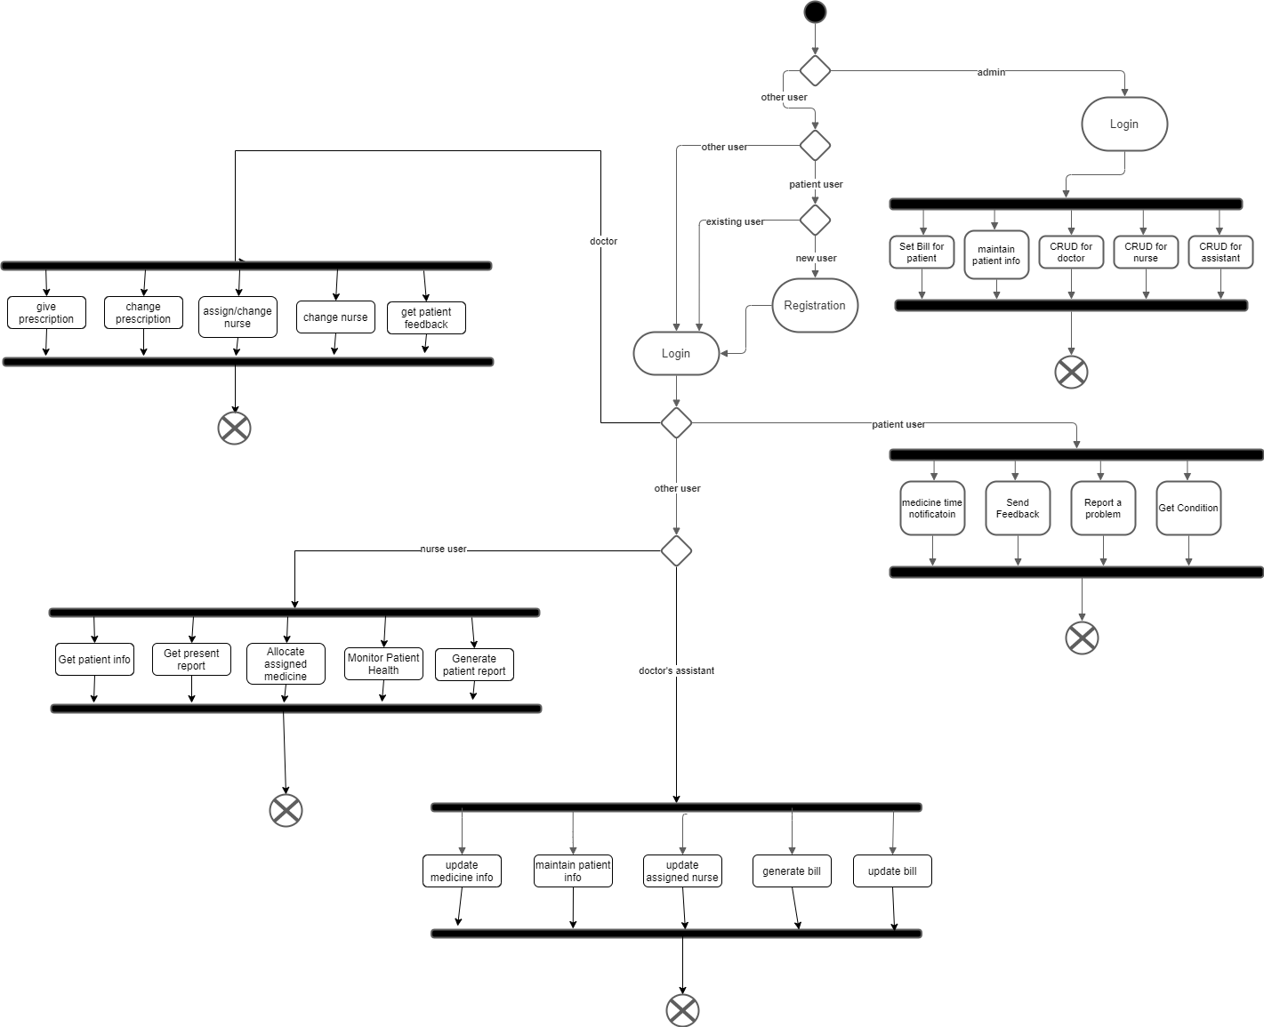

**Entity Relationship Diagram(ER)**

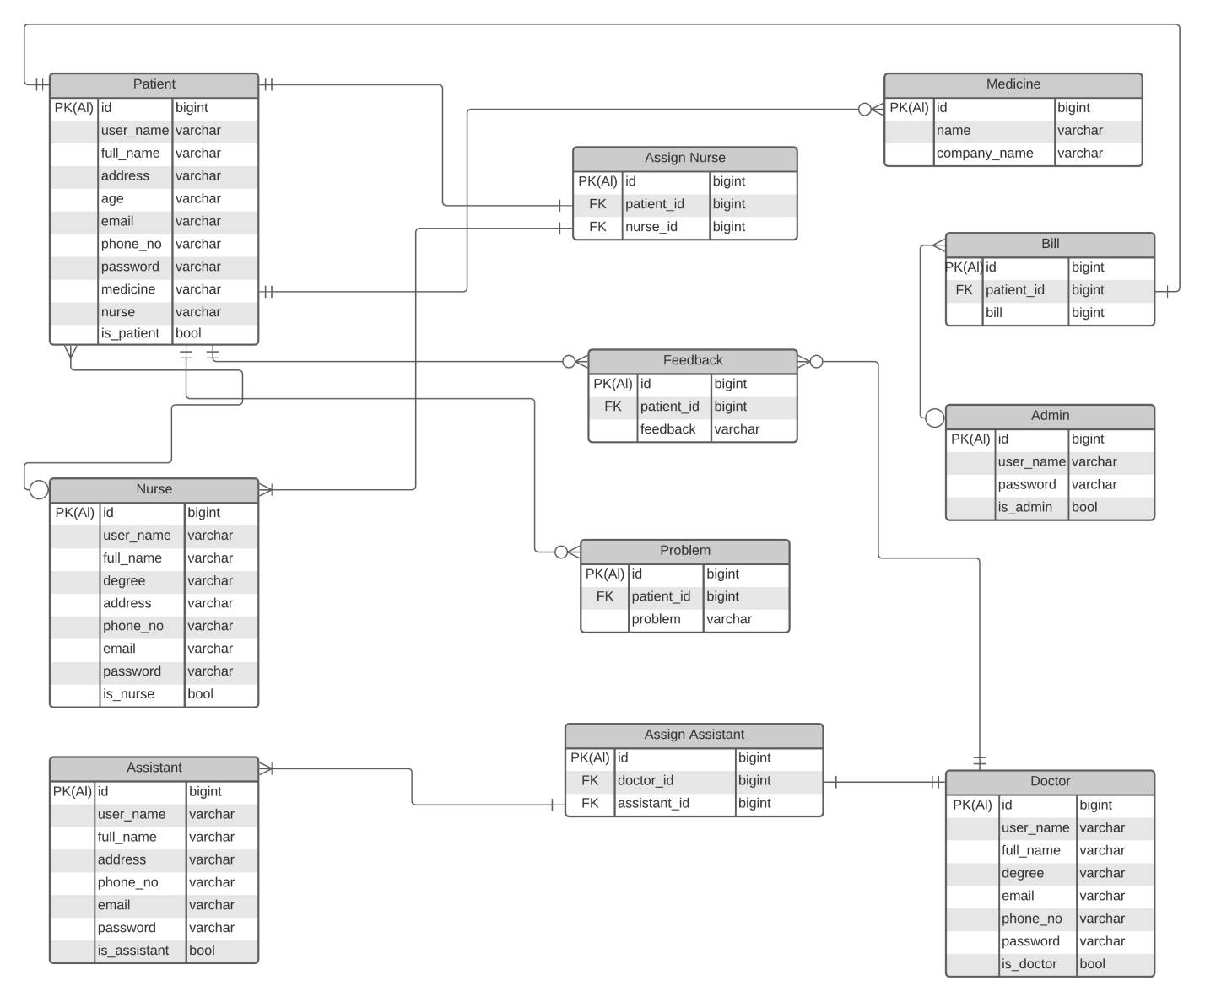

**Sequence Diagram**

Sequence Diagram for Patient

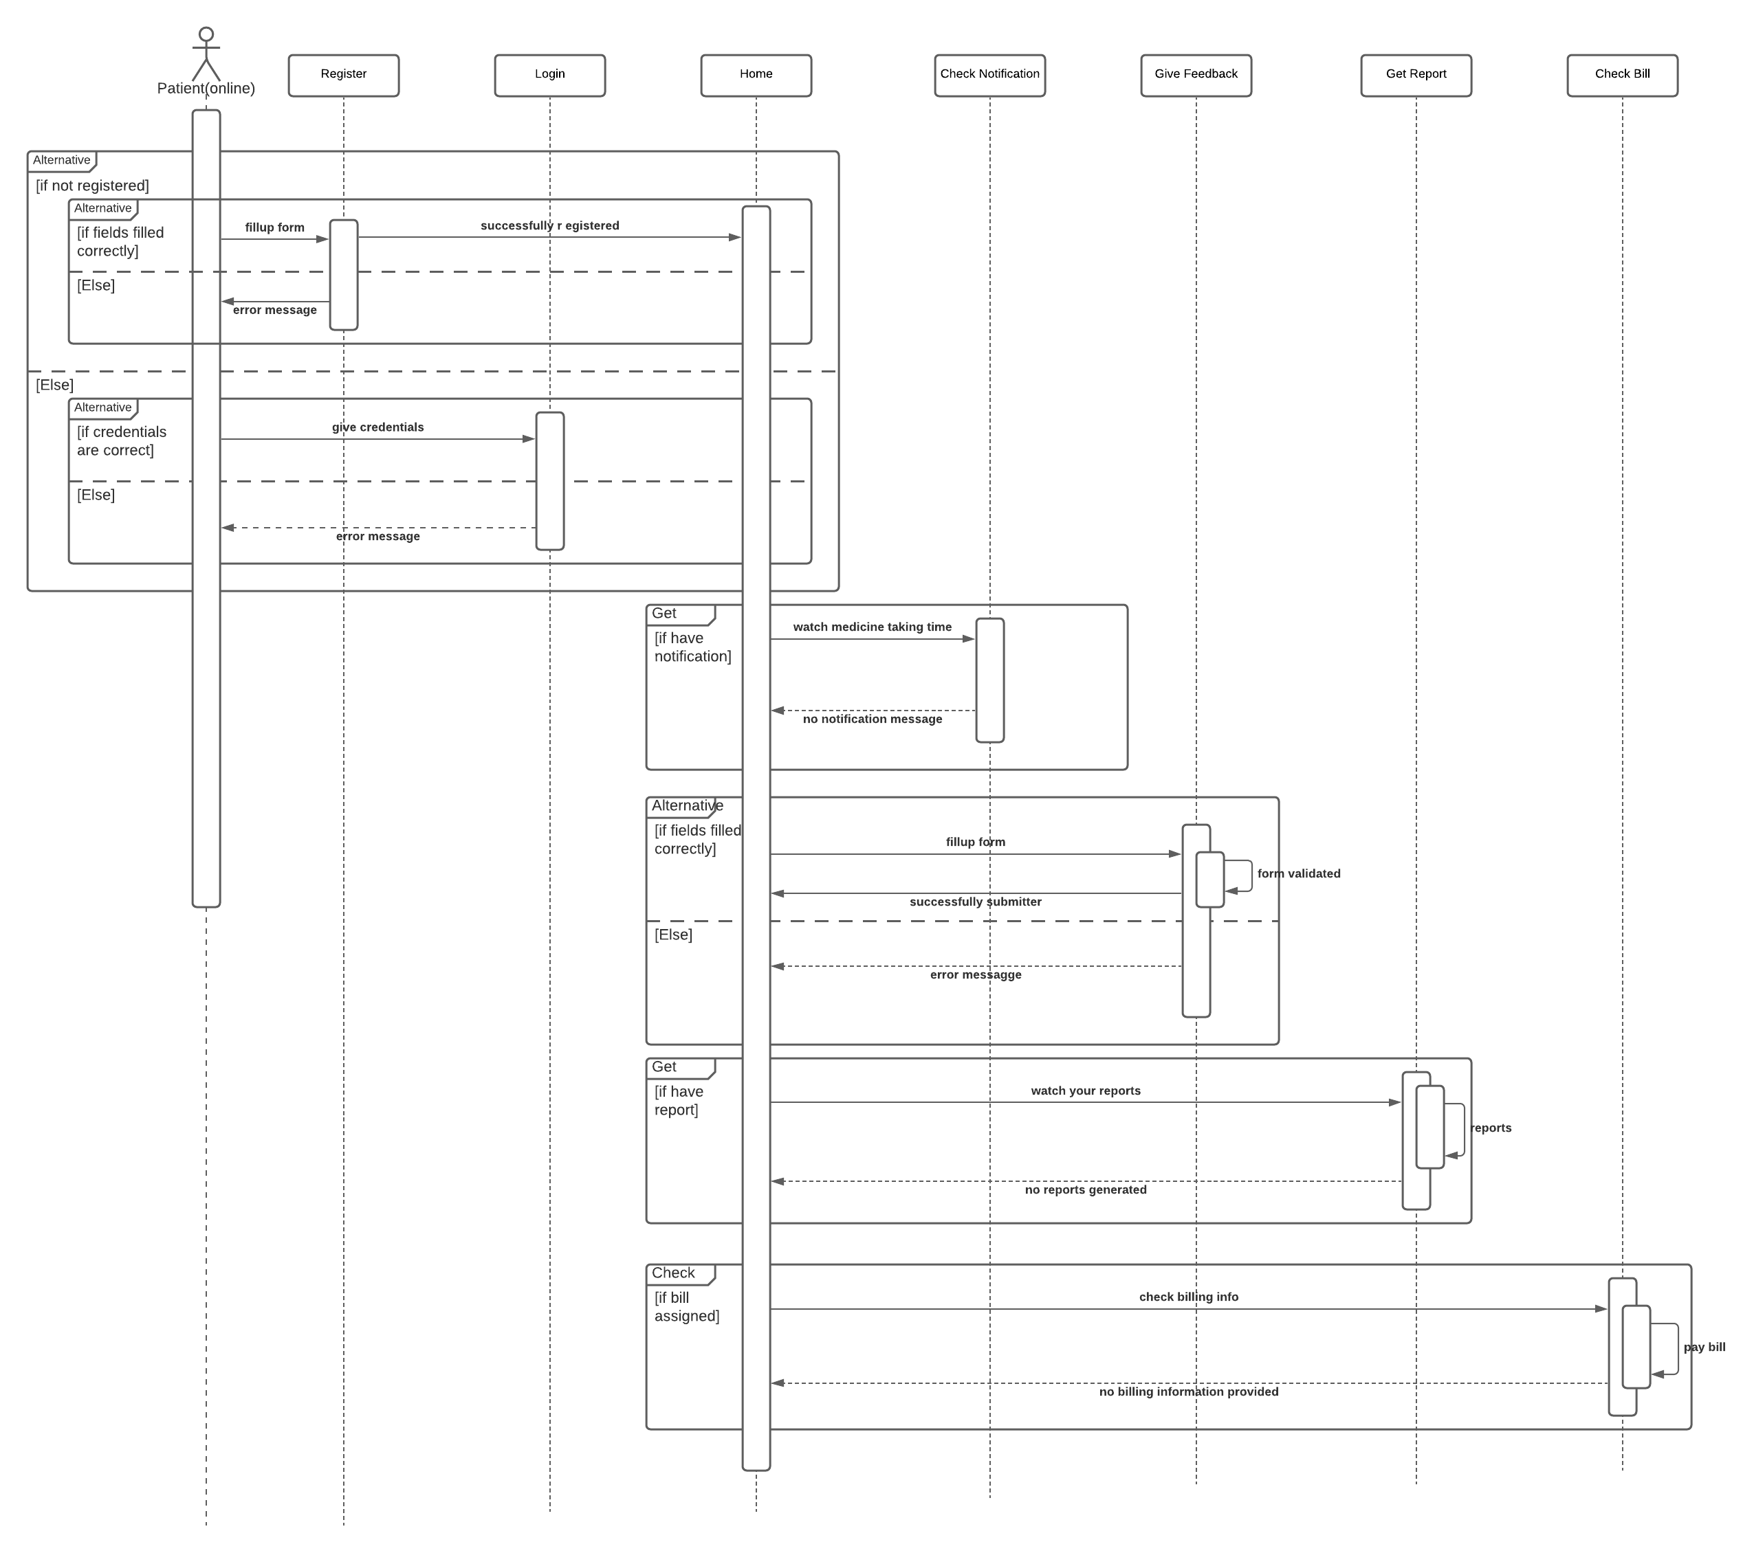

Sequence Diagram for Doctor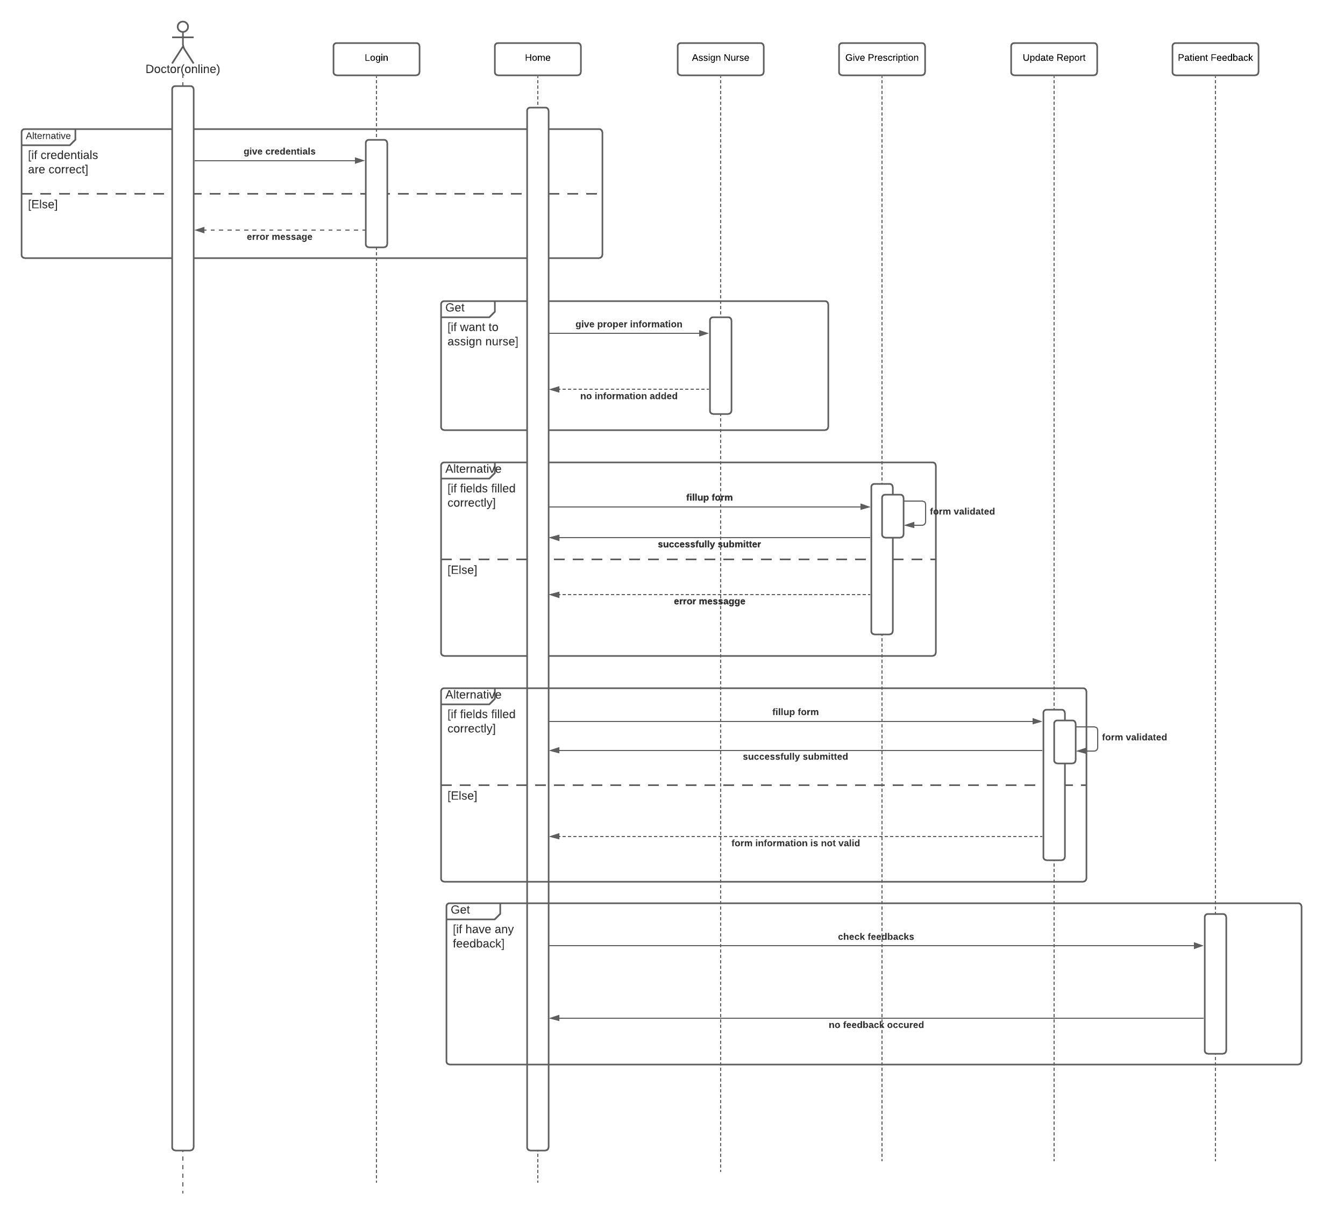

Sequence Diagram for Nurse

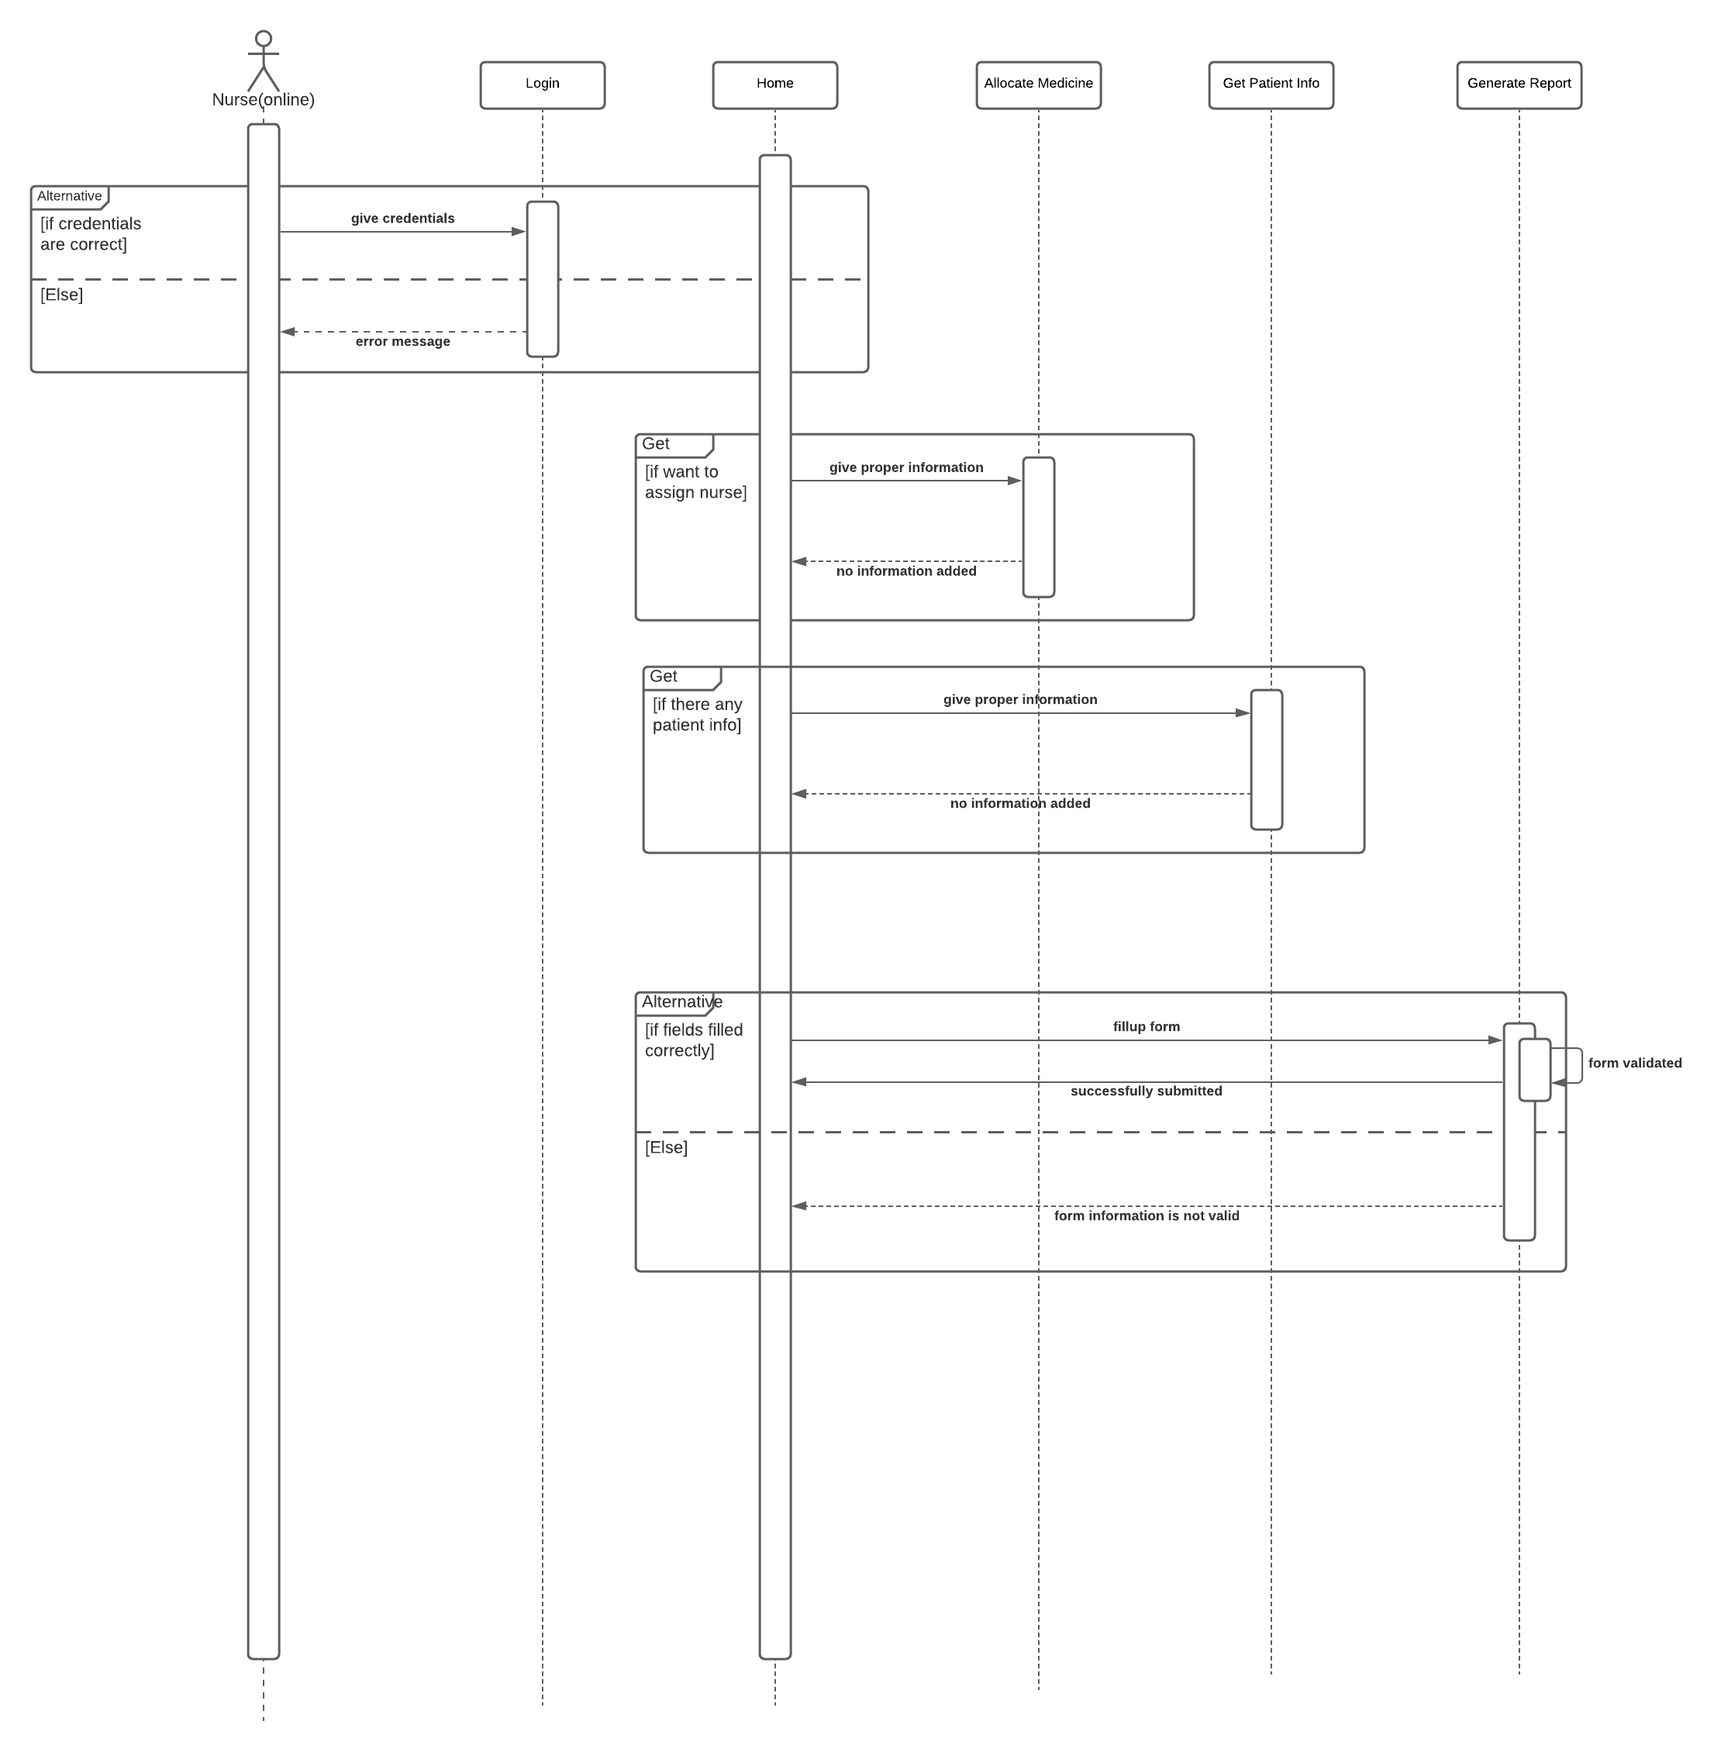

Sequence diagram for assistant

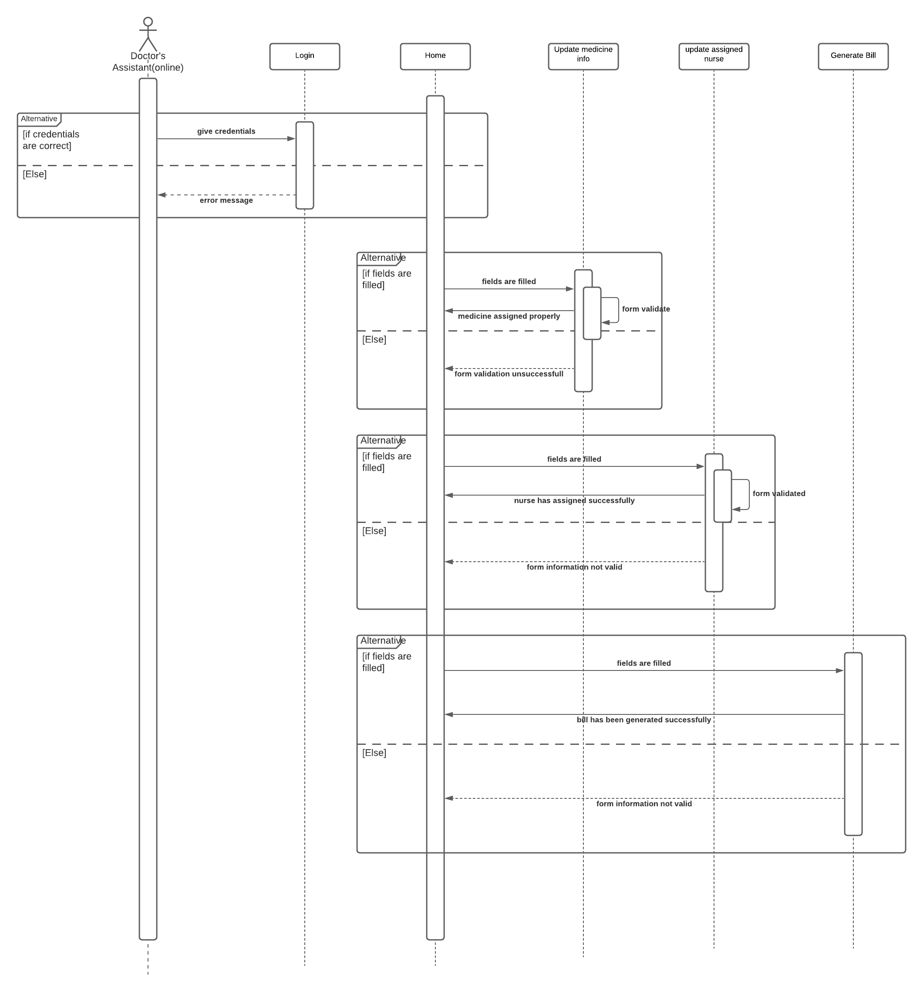

Data Flow Diagram Level 0

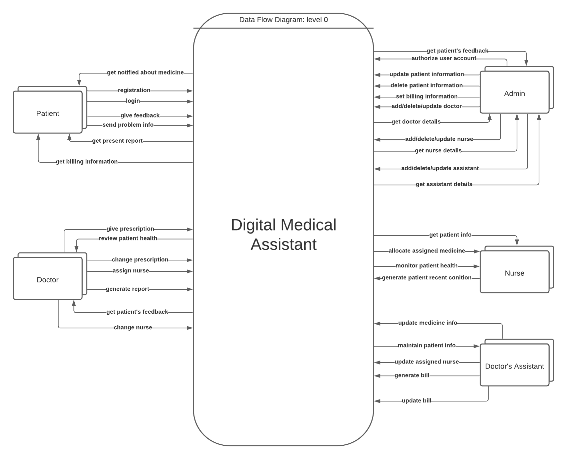

Data Flow diagram Level 1

